Evidence-Aware Pre-Payment Risk Assessment for UPI Transactions Using Behavioural, Contextual, and Payer–Payee Graph Evidence
Chinthada Murali Naga Raju, Chigurupati Vanya Kishore, Gudivada Yaswanth Naga Duga Prabhas, Bethapudi Vivek, and K. Kishore Raju
Department of Information Technology, Sagi Rama Krishnam Raju Engineering College (A), Bhimavaram, Andhra Pradesh, India
Abstract—Instant payment systems such as India’s Unified Payments Interface (UPI) settle within seconds, so the opportunity to prevent payer-authorised deception lies before the payment is submitted, when the deceived payer’s own behaviour may look normal. This paper proposes an advisory pre-payment risk-assessment architecture in which ten evidence families — payer behaviour, payee history, relationship, an incremental payer–payee graph, a calibrated gradient-boosting classifier, and address/QR, amount, message, link and stated-purpose context — declare their availability and the facts they rely on, so that risk is reported separately from evidence coverage and corroboration is credited only across distinct observations. Because labelled UPI fraud data are not public, all evaluation is synthetic. Over ten independently generated corpora of 120,000 payments, a 47-feature research representation (V2) outperforms the 12-feature prototype model (V1) on every seed (PR-AUC 0.720 ± 0.023 vs. 0.485 ± 0.022 at a realised false-positive rate of 0.99%), with gains concentrated in social engineering and mule collection and unchanged under a template-disjoint message control. A chronological replay of 180,000 payments through the running assessment path verifies that every assessment uses only pre-payment state and that the incremental graph is temporally correct. The same replay shows that the complete system ranks fraud better than its classifier alone (risk PR-AUC 0.115 ± 0.018 vs. 0.084 ± 0.004) but, with fixed rule weights, blocks 6.8 ± 0.6% of legitimate payments in a mature store, and that graph features computed from the replayed ledger do not reproduce the gain attributed to simulated graph features. The results characterise controlled synthetic conditions, not real-world performance.
Index Terms—Authorised push payment fraud, evidence aggregation, fraud risk assessment, payment graph, pre-payment assessment, probability calibration, Unified Payments Interface (UPI).

I. Introduction

A. Background and Motivation
India’s Unified Payments Interface (UPI) lets a payer address a recipient by a virtual payment address (VPA), a mobile number or a QR code and moves funds between bank accounts within seconds [1]. Because such transfers settle almost immediately and are hard to reverse, the practical opportunity to prevent loss lies between the payer’s decision to pay and the submission of the payment. Detection after settlement supports investigation, but it cannot recover money that has already been moved onward.
Payment-fraud detection is traditionally framed as classifying completed transactions against the history of the originating account [2], under extreme imbalance, delayed labels and drift [3]. This framing is weakest for authorised push payment (APP) fraud, in which the legitimate owner is deceived — by an impersonated official, a fake refund or a message that manufactures urgency — and authenticates the payment personally [4]. The payer may then pay at a familiar hour, from a familiar device and for an ordinary amount. The informative observations shift to who is being paid, how that payee has been paid by others, what the address or QR payload reveals, and what message prompted the payment.

B. Research Gap
Relational methods capture such payee-side structure, but they are usually formulated as detectors over a whole graph. FRAUDAR finds dense collusive blocks [5], Spade+ maintains dense-subgraph peeling incrementally on dynamic graphs [6], PGLTSE learns temporal graph representations for organised fraud [7], and APGNN learns fine-grained behaviour prototypes [8]. None of these is designed to supply explicit, per-payment evidence to a payer before submission. UPI-specific work has applied oversampling and gradient-boosted classifiers to transaction features and reported accuracy [9], which is uninformative at a fraud prevalence near 1% [10], [11].
Combining heterogeneous evidence before payment raises problems that the reviewed work does not address together: an unreadable source must not silently become a value, “safe” or “suspicious”; several components reading one observation must not count as independent corroboration; and relational evidence must come from the state before the payment, since a graph evaluated over a store that already holds later payments leaks the future. Moreover, evaluations typically stop at classifier metrics and do not measure what the complete evidence pipeline does to fraudulent and legitimate payments.

C. Approach and Contributions
This paper studies an advisory pre-payment risk-assessment layer for UPI-style payments. It is not a bank, payment service provider (PSP), switch or National Payments Corporation of India (NPCI) system; it neither executes nor holds payments, and it is not integrated with any of them. For a payment request, ten evidence families report a score, their availability and the typed facts they rely on; an aggregation rule reports risk separately from evidence coverage and credits corroboration only across distinct facts. The contribution lies in the pre-payment formulation, the treatment of evidence and its evaluation, not in a new learning algorithm:
- An evidence-aware pre-payment architecture that combines payer behaviour, payee history, payer–payee relationship, an incremental payer–payee graph, a calibrated gradient-boosting classifier and address/QR, amount, message, link and stated-purpose context, with explicit availability semantics and fact-aware corroboration.
- An incremental payer–payee graph that supplies interpretable relational findings, validated by a chronological replay in which every payment is assessed from the pre-payment state and inserted only afterwards.
- A robustness evaluation of the calibrated classifier over ten independently generated corpora, a feature-family ablation and a message-template-disjoint leakage control, comparing a 12-feature baseline (V1) with a 47-feature research representation (V2).
- An end-to-end evaluation of the complete ten-family pipeline through its running assessment function, which separates continuous risk from the advisory verdict mix and attributes both to individual evidence families.
All experiments use synthetic data because labelled UPI fraud data are not publicly available; results characterise controlled synthetic conditions, not real-world performance.

II. Methodology

A. Problem Formulation
A payer is about to authorise a push payment that has not yet been submitted:
$$x=\{u, p, a, t, q, m, l\} \left(1\right)$$
where $u$ is the payer, $p$ the payee address (a VPA, a mobile number or an address extracted from a QR payload), $a$ the amount, $t$ the assessment time, $q$ the raw QR payload, $m$ the message that prompted the payment and $l$ the links it carries. Every component except $p$ and $t$ may be absent. Let $H_{<t}$ be the payment observations recorded strictly before $t$, from which the payer profile, the pair history of $\left(u,p\right)$, the payee history of $p$ and the payer–payee graph $G_{<t}$ are derived. Settlement outcomes and the fraud label are unavailable at $t$. The system computes a risk score $R\left(x\right)∈\{0,…,99\}$, a coverage score $C\left(x\right)∈\{0,…,100\}$ and an advisory verdict $V\left(x\right)∈\{$APPROVE, WARN, STEP_UP, BLOCK$\}$, together with human-readable findings.
Four constraints shape the design: (i) nothing may depend on information after $t$; (ii) an unreadable source must not make the assessment more favourable, nor (iii) by itself less favourable; and (iv) one observation reported by several components is not independent corroboration.

B. Architecture and Workflow
The system comprises a client, an assessment service and a store (Fig. 1). The client decodes a QR code or accepts a typed address and optionally collects the amount, a stated purpose and the prompting message; the service evaluates and aggregates ten evidence families; the store holds an observation ledger with provenance labels, per-payee reputation aggregates, the incremental graph and payer profiles. The assessment path only reads the store. The observation path writes a payment — on the payer’s confirmation or on statement import — updating ledger, aggregates and graph in one database transaction, so the request being assessed cannot influence the state against which it is assessed. The prototype uses a Python service, scikit-learn and SQLite.

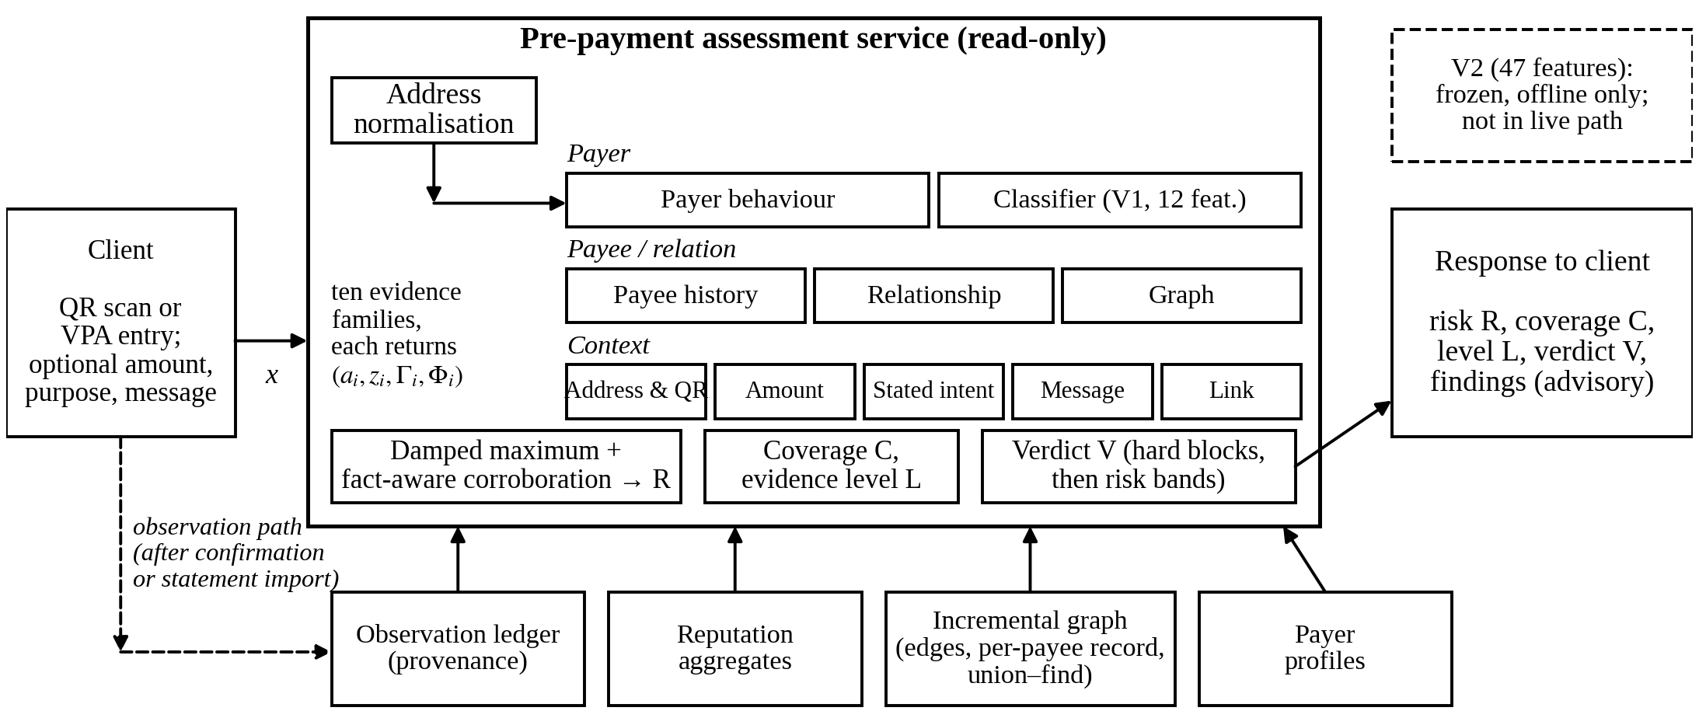
Fig. 1. Pre-payment assessment architecture. Solid arrows: read-only assessment path; dashed arrow: observation path, which writes to the store only after a payment is confirmed. The live classifier family uses V1; V2 is evaluated offline.

C. Evidence Families and Availability
Each family $i$ returns an evidence record $e_{i}=\left(a_{i},z_{i},Γ_{i},Φ_{i}\right)$: an availability flag, a score, findings and a set of facts drawn from a closed vocabulary of fourteen observations (e.g., HOUR_ANOMALY, PAYEE_SHAPE, GRAPH_POSITION, MESSAGE_COERCION). Facts name what was observed independently of which family observed it. Availability and score satisfy
$$a_{i}=1⇒z_{i}∈\{0,…,100\}, a_{i}=0⇒z_{i}=⊥, Φ_{i}=∅ \left(2\right)$$
so “looked and found nothing” is distinct from “could not look”. Table I lists the families. A never-observed but readable address keeps the payee-history family available with a low-weight “unseen payee” finding (6 points), which alone stays below the WARN band; an unreadable family contributes nothing.
TABLE I
Evidence Families
Family | Available when | Contribution to $R$ | $c_{i}$
Payee history | Address readable | Reputation shape; blocked payee → hard block | 24
Relationship | Payer known | Informational ($z=0$) | 18
Payer behaviour | Payer profile exists | 0 below raw 25, else 12–52 | 16
Classifier (V1 live) | Amount, profile, ≥5 prior payments | 0–18 below $θ$, 30–66 above | 12
Address and QR | Always | Form, handle, confusables, QR name; malformed → hard block | 11
Graph | Payee in graph | Positional findings only | 8
Amount context | Amount known | Rail limit, unfamiliar-payee size | 5
Message pressure | Message supplied | Coercion cues | 3
Link safety | Always | URL reputation | 2
Stated intent | Purpose stated | Purpose–payee fit | 1
$c_{i}$: coverage weight of (7); it values availability, not risk.

D. Incremental Payer–Payee Graph
Each confirmed payment $u→p$ increments a directed edge carrying a count and first/last timestamps, updates a per-payee record (distinct payers $N_{p}$, repeat payers, payment count, first and last arrival) and merges the components of $u$ and $p$ in a union–find structure, all in the transaction that records the payment. The assessment path reads the payee record with one indexed lookup and the peer sharing most payers with $p$ through a bounded two-hop query. With $P\left(p\right)$ the payer set of $p$ in $G_{<t}$, the overlap with a peer $p′$ is
$$ω\left(p,p′\right)=\frac{\left|P\left(p\right)∩P\left(p′\right)\right|}{min\left(\left|P\left(p\right)\right|,\left|P\left(p′\right)\right|\right)} \left(3\right)$$
Let $p^{⋆}$ maximise the shared count and $r_{p}$ be the share of $p$’s payers who paid more than once. A position finding (fact GRAPH_POSITION) fires only if both addresses have at least ten payers, $\left|P\left(p\right)∩P\left(p^{⋆}\right)\right|≥4$, $ω\left(p,p^{⋆}\right)≥0.6$ and $r_{p}<0.1$: a pattern consistent with collection accounts sharing one victim pool rather than with merchants, whose customers return. Shape findings (many one-time payers, a compressed arrival window) restate payee history and therefore carry zero weight and the PAYEE_SHAPE fact. Component size is recorded but is never a finding. The graph is explicit analytics: it is not a graph neural network, performs no dense-subgraph peeling [6] and learns no representation [7].

E. Calibrated Risk Model
The classifier is a histogram-based gradient-boosting model [12], [13] (300 iterations, learning rate 0.08, 31 leaves, balanced class weights) wrapped in five-fold isotonic calibration [14], [15]. Class weighting replaces resampling; no SMOTE [16] is used, and calibration returns the probabilities to the observed scale. Missing inputs are left missing and routed natively. The threshold $θ$ is the value with the highest validation recall subject to a validation false-positive rate (FPR) of at most 1%. The calibrated probability $π$ is mapped to a bounded family score
$$z_{ml}=\left\{\begin{matrix}round g\left(π;0,θ,0,18\right), & π<θ \\ round g\left(π;θ,0.8,30,66\right), & π≥θ\end{matrix}\right. \left(4\right)$$
where $g\left(v;v_{0},v_{1},y_{0},y_{1}\right)$ maps $\left[v_{0},v_{1}\right]$ linearly onto $\left[y_{0},y_{1}\right]$ with clipping. The ceiling of 66 keeps the classifier alone below BLOCK. Facts are attributed to the classifier counterfactually: a fact is declared only if neutralising its inputs lowers $π$ by at least $max\left(0.01,0.15π\right)$.

F. Evidence Aggregation and Verdict
Let $z_{\left(1\right)}≥…≥z_{\left(n\right)}$ be the scores of active families ($a_{i}=1$, $z_{i}>0$). The strongest signal leads and further signals are damped:
R0=min​99, round​z1+0.4j≥2​zj 5
Let $A^{⋆}$ be the families with $z_{i}≥20$ that declare facts and $Φ^{⋆}$ the union of their facts. Corroboration counts both streams and observations:
$$k=min\left(\left|Φ^{⋆}\right|,\left|A^{⋆}\right|\right), R=min​\left(99, R_{0}+B\left(k\right)\right) \left(6\right)$$
with $B\left(k\right)=0$ for $k<2$ and $B=6,14,22,28,32$ for $k=2,…,≥6$. Counting families prevents one family from corroborating itself, and counting distinct facts prevents families that read one observation from appearing to agree. Coverage depends only on availability,
C=round​100i​aici/i​ci 7
and an evidence level is FULL when payee history, payer behaviour and relationship are all available, and PARTIAL or MINIMAL otherwise. With $B$ the hard-block findings (blocked payee, malformed address, non-payment payload, amount above the rail limit),
$$V=\left\{\begin{matrix}\text{BLOCK}, & Γ∩B≠∅\text{ or }R≥70 \\ \text{STEP_UP}, & 45≤R≤69 \\ \text{WARN}, & 22≤R≤44 \\ \text{APPROVE}, & R≤21\end{matrix}\right. \left(8\right)$$
The bands are fixed design parameters. The verdicts are advisory states of one score, not ground-truth classes, and no verdict holds or reverses a payment. Each response lists its findings, the facts that participated in corroboration with the families that reported them, and the families that could not be evaluated, with reasons; these findings are the user-facing explanation (Fig. 2).
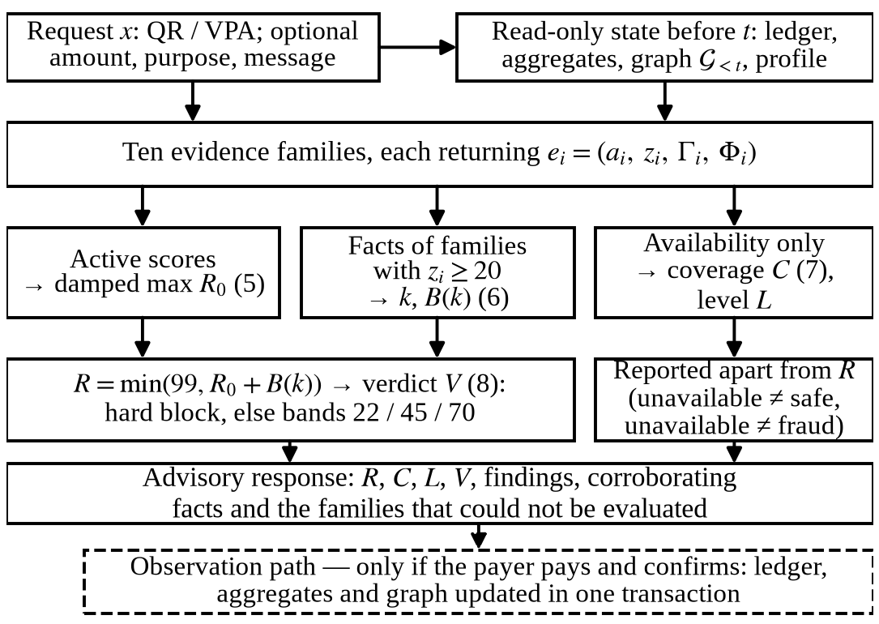
Fig. 2. Pre-payment evidence and risk-assessment workflow. The assessment at time t reads only state recorded before t; risk (5)–(6) and coverage (7) are computed separately; the observation is written only after the payer confirms.

III. Experimentation

A. Synthetic Data
Labelled UPI fraud data held by banks, PSPs and NPCI are not publicly released, and none were used. Two synthetic corpora in the tradition of agent-based payment simulators [17] are used instead (Table II); their scenarios, overlaps and channel probabilities were specified by the authors, so every result characterises controlled synthetic conditions.
Row-level corpus (Experiments 1–2). Each seed generates 120,000 payments from 2,000 payers at a nominal fraud rate of 0.012 (seed 42: 1,419 fraudulent, 1.183%) with a fixed mixture of social engineering (SE) 50%, mule collection (MC) 22%, account takeover (AT) 20% and card testing (CT) 8%. Each row is the evidence state just before one payment, sampled from scenario-conditional distributions that deliberately overlap with legitimate behaviour; payee history is hidden on 24.48% of rows (seed 42). The V2 relationship, graph, message, link and intent channels are simulator-generated, with messages drawn from a pool of 1,022 templates (364 scam, 557 hard and 101 easy negatives) written for the project.
Replay streams (Experiments 3–4). Because the row-level corpus has no identities or clock, identity-bearing streams were generated for seeds 42–44: 60,000 time-ordered payments over 150 days by 2,000 payers to 900 merchants (Zipf-like popularity, 30% opening during the window) and to fraud-controlled addresses, with 720 fraudulent payments each (SE 360, MC 158, AT 144, CT 58). SE collectors receive Poisson(7)+2 victims, 35% through an aged address; MC rings of 3–4 accounts collect from 20–45 victims, 60% of whom pay two ring accounts. Payer behaviour and the message, link and intent channels reuse the row-level generators and template pool.
TABLE II
Data and Feature Representations
Item | Value
Row-level corpus | 120,000 payments, 2,000 payers per seed; seeds 42–51
Split (stratified) | 72,000 / 18,000 / 30,000 (train / val. / test)
Test fraud | 355 at seed 42; 341–383 over seeds
Replay streams | Seeds 42–44; 60,000 payments, 150 days, 720 fraud each
V1 (live baseline) | 12: payer timing and amount 4, velocity 3, payee 5
V2 (offline research) | 47: payer 2, amount 2, velocity 3, payee 5, relationship 4, graph 7, message 18, link 3, intent 3
Learner (V1, V2) | HGB, balanced weights, 5-fold isotonic calibration
V1 is served by the prototype; V2 was frozen and evaluated offline and is not deployed.

B. Protocol and Metrics
For every corpus, 25% of rows are held out as test and 20% of the remainder as validation, stratified on the label with the seed as random state. Models are fitted on training rows only; $θ$ is chosen on validation (FPR ≤ 1%) and applied once to the test split. PR-AUC (average precision) is the primary metric because it reflects alert dilution under imbalance [10], [11]; ROC-AUC is secondary. At $θ$ we report recall, realised FPR, precision, F1 and per-scenario recall, and the Brier score with its skill score (BSS) against the base-rate predictor [18].

C. Experiments 1–2: Stability and Ablation
Ten-seed stability. The whole pipeline — generation, split, fitting, calibration, threshold selection, test measurement — is repeated for seeds 42–51. The seed is the unit of replication: statistics are summarised as mean ± sample sd, minimum and maximum over ten seed-level values; test sets are never pooled and no seed is selected.
Feature-family ablation. Eleven configurations use the same seeds, splits, learner and threshold rule: A, V1; B, a 12-feature V2 core (payer timing, amount, velocity, payee); C–G, core plus one of relationship, graph, message, link or intent; H, core + relationship + graph; I, H + message; J, I + link; K, full V2. Differences are paired by seed and given in percentage points (pp). Because train and test messages share one template pool on which the coercion model was fitted, a template-disjoint control repeats E, I and K after splitting the templates 50/50 within each kind, refitting the coercion model on the training half, and giving test rows only held-out templates.

D. Experiments 3–4: End-to-End Evaluation and Graph Replay
Each replay stream is processed in time order (Fig. 3). For each payment the clock is set to its time $t$; the payer’s prior payments and the shared store, which holds only earlier payments, form the pre-payment state; the production assessment function behind the service’s check endpoint returns risk, coverage, level, verdict, per-family evidence and findings; and only then is the payment recorded through the production observation path. The live classifier family uses the stored V1 artefact without refitting. The only runtime substitution is the injected clock, because payee age is computed from the application’s “now”.
End-to-end metrics. Continuous risk is evaluated with PR-AUC and ROC-AUC, separately from the verdict mix, which is reported as an intervention profile and as operating points of $R$ — not as classes. The primary slice is the last 25% of each stream (days ≈112–150); 30-day blocks show the effect of store maturity. Per family we report activation by label, the within-available AUC of its score and a leave-one-family-out counterfactual that re-applies (5)–(8). Every recorded output is also recomputed from the recorded evidence as a consistency audit.
Graph replay tests. A plain-Python shadow model of all earlier payments is checked at every read: (1) a first pair is new; (2) the prior pair count, (3) distinct payers, (4) the arrival window and (5) the connected component equal the shadow; (6) a positional finding fires exactly when its gates hold; (7) an unobserved payee has unavailable, not zero, graph evidence; and (10) the store holds no payment at or after $t$. Afterwards, (8) an independent process rebuilds a fresh store from earlier payments only and recomputes the full assessment for up to 60 stratified payments per stream, and (9) every observation written before the stream midpoint must be unchanged at the end. The predictive value of replayed graph features is measured on a chronological 60/15/25 split with four variants: A, V1 from the replayed state; B, V2 with the graph columns replaced by the row-level simulator’s graph channel (a contrast only, since that channel is conditioned on the true scenario); C, V2 with replayed graph features; D, V2 without graph features.
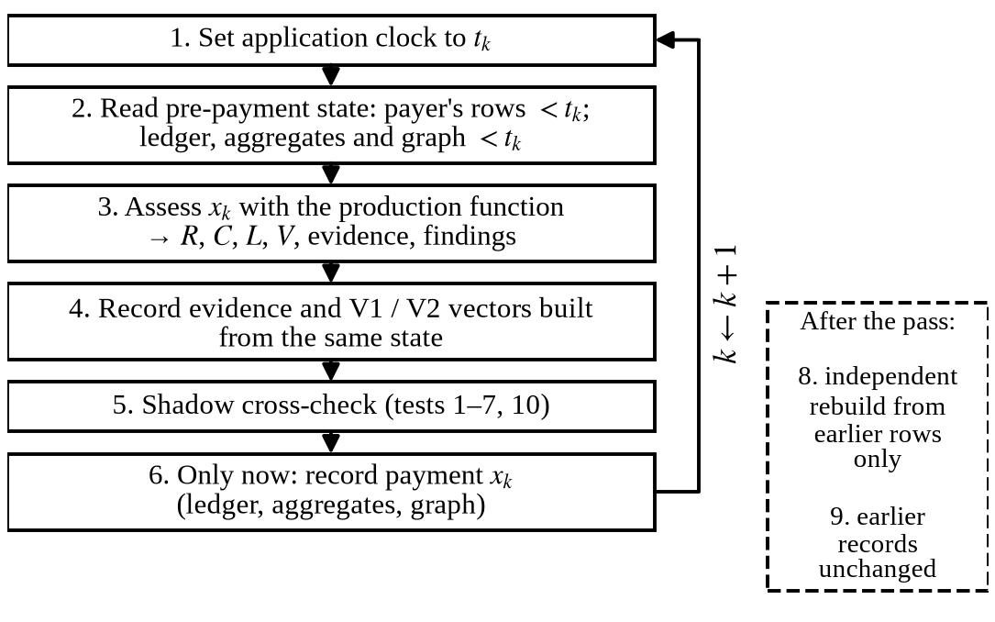
Fig. 3. Chronological replay. For each payment at time t: set the clock, read state before t, assess with the production function, record the evidence, cross-check against a shadow model, and only then record the payment. Tests 8–9 are run afterwards.
A leakage audit grades, from artefacts and recomputation, split disjointness for every seed, validation-only threshold selection, the absence of test-derived preprocessing, the pre-payment boundary of every replayed assessment (tests 1–10) and message-template overlap as PASS, FAIL or WARNING.

IV. Results and Discussion
All results are synthetic. Sections IV-A to IV-C concern the classifier on the row-level corpus; IV-D concerns the complete ten-family system and IV-E the graph, both on the replay stream.

A. Original Baseline: V1 and V2 at Seed 42
On the original test split (30,000 payments, 355 fraudulent), V1 reaches a PR-AUC of 0.4860 and a ROC-AUC of 0.9652 and, at its validation threshold (0.1174), a recall of 49.3% at an FPR of 0.945% (precision 0.3846, F1 0.4321; TP = 175, FN = 180, FP = 280). The frozen V2 model reaches a PR-AUC of 0.7326, a ROC-AUC of 0.9900 and, at 0.1123, a recall of 0.7803 at an FPR of 0.00995 (precision 0.4843, F1 0.5976; TP = 277, FN = 78, FP = 295), with a Brier score of 0.00555 (BSS 0.525). Social-engineering recall is 19.23% for V1 and 65.93% for V2. Refitting both models with the experiment code reproduces these values exactly, which ties the new experiments to the original artefacts.

B. Ten-Seed Stability
Table III summarises the ten independently generated corpora. The V1–V2 ordering holds on every seed: V2 has the higher PR-AUC, recall, precision, F1 and BSS and the lower Brier score in 10 of 10 paired comparisons, and the paired PR-AUC difference is +0.235 ± 0.027 (range +0.189 to +0.271). The seed-to-seed standard deviation of PR-AUC (≈0.02) is the scale against which any single-split difference should be read. The original V2 value (0.7326) lies above the V2 mean of 0.720 but inside its range (0.683–0.769); the original V1 value (0.4860) is close to its mean of 0.485. Both models operate at the same realised FPR (0.99 ± 0.08%), so the recall gain (+26.2 ± 3.2 pp) is not bought with extra false alarms. Because thresholds are chosen on validation, the test FPR exceeds the 1% budget on five V1 and three V2 seeds, by at most 0.17 pp.
The gain is scenario-specific. Social-engineering recall rises from 20.5 ± 2.7% to 62.4 ± 4.5% and mule-collection recall from 61.2 ± 5.5% to 83.0 ± 3.7% on every seed, whereas account-takeover (≈93%) and card-testing (≈97%) recall do not differ systematically (V2 higher on only 5 and 2 seeds). The additional channels matter where the payer behaves normally.

TABLE III
Ten-Seed Stability of V1 and V2 (Row-Level Corpus, Seeds 42–51, Held-Out Test Splits of 30,000 Payments)
Metric | V1 mean ± sd | V1 min–max | V2 mean ± sd | V2 min–max | Δ (V2 − V1) | Seeds V2 better
PR-AUC | 0.485 ± 0.022 | 0.456–0.513 | 0.720 ± 0.023 | 0.683–0.769 | +0.235 ± 0.027 | 10/10
ROC-AUC | 0.966 ± 0.002 | 0.963–0.970 | 0.988 ± 0.002 | 0.983–0.991 | +0.022 ± 0.002 | 10/10
Recall (%) | 49.4 ± 2.2 | 46.2–52.3 | 75.7 ± 3.2 | 70.8–81.0 | +26.2 ± 3.2 pp | 10/10
FPR (%) | 0.99 ± 0.08 | 0.88–1.12 | 0.99 ± 0.08 | 0.90–1.17 | +0.00 ± 0.11 pp | 3/10
Precision (%) | 37.9 ± 1.9 | 35.9–42.1 | 48.2 ± 2.4 | 44.4–52.4 | +10.3 ± 2.6 pp | 10/10
F1 (%) | 42.8 ± 1.6 | 40.4–46.2 | 58.8 ± 2.4 | 55.6–63.6 | +16.0 ± 2.4 pp | 10/10
Brier (×10⁻³) | 8.13 ± 0.35 | 7.71–8.94 | 5.73 ± 0.30 | 5.16–6.14 | −2.40 ± 0.32 | 10/10
BSS | 0.315 ± 0.018 | 0.284–0.340 | 0.517 ± 0.023 | 0.486–0.569 | +0.202 ± 0.024 | 10/10
SE recall (%) | 20.5 ± 2.7 | 14.7–24.1 | 62.4 ± 4.5 | 56.0–67.8 | +41.9 ± 4.4 pp | 10/10
MC recall (%) | 61.2 ± 5.5 | 48.6–67.1 | 83.0 ± 3.7 | 76.5–89.3 | +21.7 ± 6.7 pp | 10/10
AT recall (%) | 93.3 ± 3.8 | 86.1–97.3 | 93.6 ± 3.1 | 88.9–98.7 | +0.3 ± 2.7 pp | 5/10
CT recall (%) | 96.7 ± 3.1 | 92.6–100.0 | 97.3 ± 3.1 | 92.6–100.0 | +0.6 ± 2.6 pp | 2/10
Statistics are over the ten seed-level values (sample sd); test sets are not pooled. Δ is the paired per-seed difference. SE, MC, AT, CT: social engineering, mule collection, account takeover, card testing.
TABLE IV
Feature-Family Ablation (Mean Over Seeds 42–51; Recall, FPR, Precision, F1 and Scenario Recall in %)
Configuration | F | PR-AUC | ΔPR-AUC vs B (pp) | ROC-AUC | Recall | FPR | Prec. | F1 | SE | MC | AT | CT
A. V1 baseline | 12 | 0.485 ± 0.022 | +0.2 ± 1.2 | 0.966 | 49.4 | 0.99 | 37.9 | 42.8 | 20.5 | 61.2 | 93.3 | 96.7
B. V2 core | 12 | 0.483 ± 0.026 | — | 0.946 | 50.8 | 1.02 | 37.8 | 43.3 | 22.8 | 63.5 | 92.5 | 93.3
C. Core + relationship | 16 | 0.511 ± 0.025 | +2.8 ± 0.7 | 0.969 | 52.5 | 1.01 | 38.8 | 44.5 | 25.8 | 64.0 | 92.9 | 94.7
D. Core + graph | 19 | 0.595 ± 0.026 | +11.2 ± 1.5 | 0.962 | 60.8 | 0.99 | 42.8 | 50.2 | 35.8 | 77.1 | 94.0 | 94.6
E. Core + message | 30 | 0.557 ± 0.028 | +7.5 ± 1.9 | 0.963 | 59.5 | 0.98 | 42.5 | 49.6 | 40.5 | 62.4 | 92.9 | 92.9
F. Core + link | 15 | 0.500 ± 0.026 | +1.7 ± 0.7 | 0.949 | 52.2 | 1.00 | 38.8 | 44.5 | 25.3 | 64.8 | 92.2 | 92.7
G. Core + intent | 15 | 0.523 ± 0.023 | +4.0 ± 1.0 | 0.954 | 55.4 | 1.06 | 38.9 | 45.7 | 31.3 | 65.3 | 92.7 | 91.5
H. Core + rel. + graph | 23 | 0.623 ± 0.024 | +14.0 ± 0.9 | 0.980 | 63.5 | 1.03 | 42.9 | 51.1 | 39.4 | 81.8 | 92.4 | 96.5
I. H + message | 41 | 0.684 ± 0.026 | +20.1 ± 2.6 | 0.986 | 72.6 | 0.99 | 47.1 | 57.1 | 56.8 | 82.8 | 92.6 | 98.0
J. I + link | 44 | 0.685 ± 0.025 | +20.2 ± 2.4 | 0.986 | 72.7 | 0.99 | 47.2 | 57.2 | 56.8 | 83.0 | 92.3 | 98.0
K. Full V2 (I + link + intent) | 47 | 0.720 ± 0.023 | +23.7 ± 2.7 | 0.988 | 75.7 | 0.99 | 48.2 | 58.8 | 62.4 | 83.0 | 93.6 | 97.3
E† Core + message, template-disjoint | 30 | 0.558 ± 0.028 | +7.5 ± 1.8 | 0.962 | 59.9 | 1.01 | 41.8 | 49.2 | 41.1 | 63.0 | 92.5 | 92.9
I† H + message, template-disjoint | 41 | 0.682 ± 0.023 | +19.9 ± 2.6 | 0.986 | 71.7 | 0.96 | 47.8 | 57.3 | 56.0 | 80.9 | 92.2 | 97.1
K† Full V2, template-disjoint | 47 | 0.715 ± 0.022 | +23.3 ± 2.4 | 0.988 | 75.5 | 1.01 | 47.6 | 58.3 | 62.3 | 82.4 | 93.7 | 97.3
F: number of features. ΔPR-AUC is paired by seed against the V2 core (B). † Template-disjoint control: test messages come from templates never seen in training and the coercion model is refitted on the training half.

C. Feature-Family Ablation
Table IV and Fig. 4 report the ablation. The 12-feature V2 core (B) matches V1 (A) in PR-AUC (0.483 vs. 0.485); its lower ROC-AUC reflects that payer-relative payee novelty belongs to the relationship group. Every single-family addition to the core raises PR-AUC on all ten seeds. The graph group is associated with the largest single gain (+11.2 ± 1.5 pp) and with the largest increase in mule-collection recall (63.5% → 77.1%). The message group adds +7.5 ± 1.9 pp and is associated with the largest single increase in social-engineering recall (22.8% → 40.5%) but leaves mule-collection recall unchanged. Stated intent (+4.0 pp), relationship (+2.8 pp) and link (+1.7 pp) contribute less.
The cumulative sequence shows complementarity rather than redundancy between the graph and message groups: relationship and graph together (H) reach +14.0 pp, message adds a further +6.1 ± 2.0 pp (I) with social-engineering recall rising from 39.4% to 56.8%, link adds nothing measurable once messages are present (+0.1 ± 0.6 pp; J), and intent adds +3.5 ± 1.4 pp (K). Account-takeover and card-testing recall stay within 91–98% in every configuration. These are associations under the simulator: the ablation measures how much of each designed channel’s signal the learner recovers, not how informative the channel would be on real payments.
Template-disjoint control. With the standard protocol, 99.9–100% of test messages reuse a template that also occurs in training rows. When test messages are restricted to held-out templates and the coercion model is refitted on the training half (E†, I†, K† in Table IV), the full-V2 PR-AUC changes by −0.4 ± 0.7 pp (0.715 ± 0.022 vs. 0.720 ± 0.023) and social-engineering recall by −0.1 ± 1.5 pp; the core + message configuration changes by +0.0 ± 0.9 pp. Exact-template memorisation therefore does not explain the message-channel gain. Both halves of the pool were, however, written by the same authors, so generalisation to real scam language remains untested.
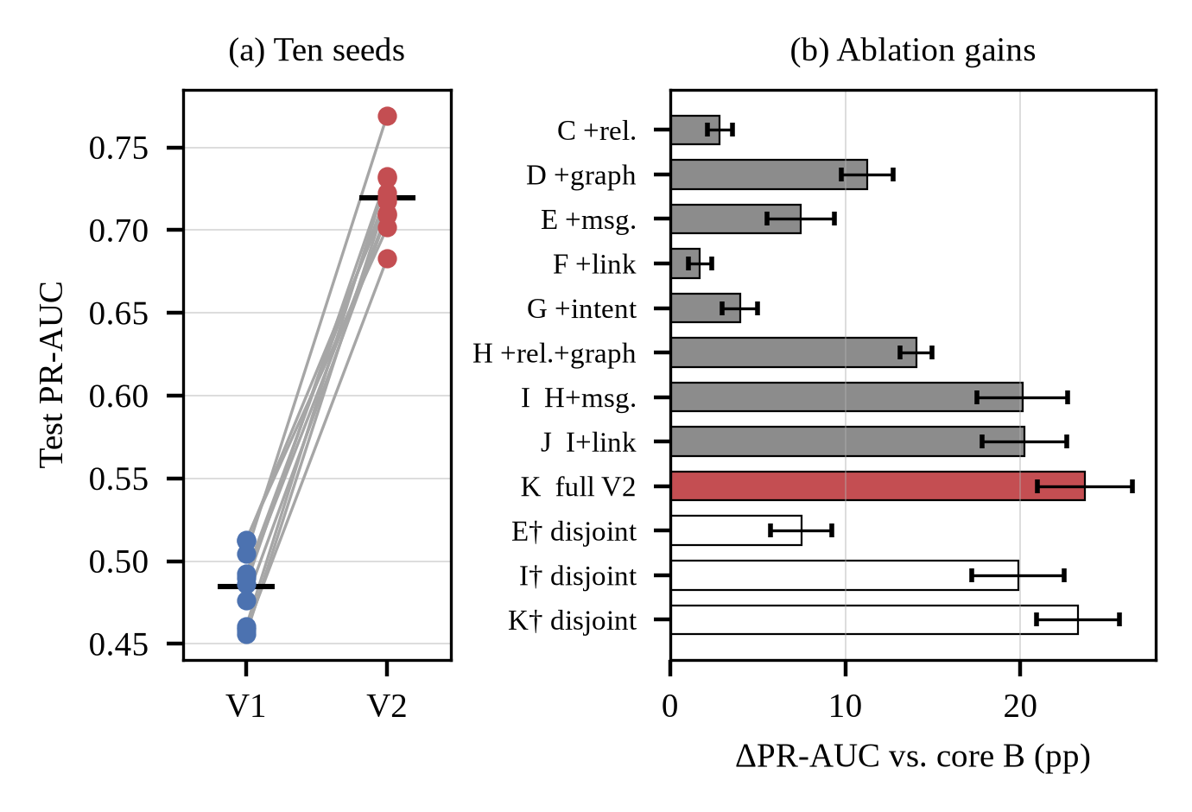
Fig. 4. Classifier robustness on the row-level corpus. (a) Per-seed test PR-AUC of V1 and V2 for seeds 42–51 (lines pair seeds; bars show means). (b) Paired PR-AUC gain over the V2 core for each ablation configuration (mean ± sd over seeds); † marks the template-disjoint controls.

D. End-to-End Ten-Family Evaluation
Values are mean ± sd over the three replay streams, for the last 25% of each stream unless stated otherwise. For all 180,000 assessed payments, the recorded risk, coverage, evidence level, corroboration bonus and verdict were reproduced exactly from the recorded per-family evidence (0 mismatches), so the results describe the aggregation of Section II-F as executed.
Risk and verdicts. The ten-family risk $R$ reaches a PR-AUC of 0.115 ± 0.018 and a ROC-AUC of 0.848 ± 0.014 at a prevalence of about 1.40% (Table V); on the same payments the live V1 probability alone reaches 0.084 ± 0.004 and 0.840 ± 0.015. Aggregation thus ranks fraud better than the classifier it contains. Its verdicts, however, differ sharply from the classifier’s 1% budget (Fig. 5): legitimate payments receive APPROVE in 65.3 ± 0.7%, WARN in 22.1 ± 0.6%, STEP_UP in 5.8 ± 0.5% and BLOCK in 6.8 ± 0.6% of cases. Social-engineering and mule-collection payments are blocked in 71.2 ± 15.0% and 57.6 ± 3.8% of cases, account-takeover payments in 19.5 ± 2.1%, and card-testing probes — small payments to shared addresses — are approved in 82.5 ± 7.3%. As operating points, WARN or above recalls 82.2 ± 2.6% of fraud at an FPR of 34.7 ± 0.7%, and BLOCK recalls 50.3 ± 5.7% at 6.8 ± 0.6%. No threshold on $R$ meets a 1% FPR budget on the window preceding the evaluation slice, because 2.4 ± 1.1% of legitimate payments there already reach the cap $R=99$.
Why legitimate payments are blocked. The leading family of a blocked legitimate payment is stated intent in 50 ± 5% of cases, message pressure in 26 ± 3% and payee history in 13 ± 9%. The dominant finding is a refund purpose, which the stated-intent rule treats as decisive although the simulator, like everyday life, also generates honest refunds; bank messages written with pressure vocabulary act similarly on the message family. Early in each stream a third cause dominates: payee age is measured from the first observation in the store, so popular merchants initially look young and busy and trigger the collection-account rule. The share of legitimate payments blocked falls from 30.9 ± 0.3% in the first 30 days to 6.5 ± 0.5% in the last 30, while fraud BLOCK recall per block stays within 34–62% (Fig. 5c).
Families, corroboration and coverage. Payer behaviour is active for nearly all fraud and most often leads a fraudulent assessment; removing it lowers the verdict of 36 ± 4% of fraudulent and 21 ± 1% of legitimate payments (Table VI). Payee history is active for 44 ± 6% of fraud but 11 ± 1% of legitimate payments. Address and QR evidence fires almost only on fraud, because the replay gives some collectors brand-lure handles and mismatched QR names. The relationship family never scores by design, and the positional graph finding fired on only 18 of 2,160 fraudulent and 0 legitimate payments. Over the full streams a corroboration bonus is paid for 65 ± 1% of fraudulent and 18 ± 0% of legitimate payments; counting distinct facts rather than families changed the bonus for only 3 payments, so double counting is rare under this design rather than frequently corrected. No unavailable family ever carried a score, and coverage is high for both classes (median 96 and 97) and only weakly related to risk (Spearman −0.16 ± 0.01).

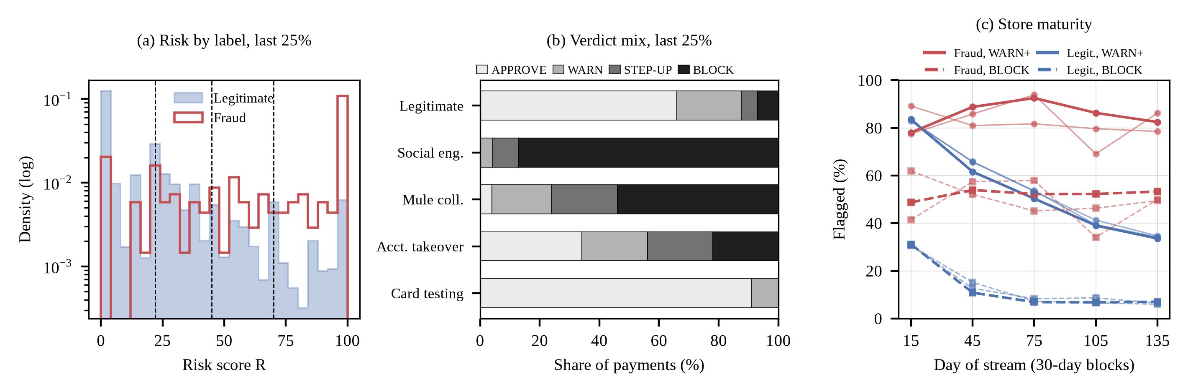
Fig. 5. End-to-end ten-family evaluation on the chronological replay. (a) Risk distribution by label in the last 25% of stream 42, with the WARN, STEP_UP and BLOCK boundaries. (b) Advisory verdict mix by group, stream 42. (c) Share of legitimate and fraudulent payments flagged per 30-day block as the store matures (stream 42 bold, streams 43–44 thin).
TABLE V
Replay Streams: Complete System vs. Classifier Variants (Last 25% of Each Stream; %, Mean ± sd Over Streams)
Replay stream, last 25% | PR-AUC | ROC-AUC | Recall | FPR | Precision | SE | MC | AT | CT
System: WARN or above | 0.115 ± 0.018 | 0.848 ± 0.014 | 82.2 ± 2.6 | 34.7 ± 0.7 | 3.2 ± 0.4 | 96 ± 4 | 95 ± 1 | 63 ± 3 | 17 ± 7
System: STEP_UP or above | ″ | ″ | 66.6 ± 4.3 | 12.6 ± 0.8 | 7.0 ± 0.6 | 87 ± 9 | 76 ± 1 | 38 ± 5 | 5 ± 5
System: BLOCK | ″ | ″ | 50.3 ± 5.7 | 6.8 ± 0.6 | 9.5 ± 1.1 | 71 ± 15 | 58 ± 4 | 19 ± 2 | 4 ± 3
Live V1 alone, $θ$ = 0.1174 | 0.084 ± 0.004 | 0.840 ± 0.015 | 5.5 ± 0.2 | 0.06 ± 0.02 | 55.4 ± 10.0 | 1 ± 1 | 20 ± 3 | 0 ± 0 | 0 ± 0
A. V1, refitted on replay | 0.586 ± 0.037 | 0.946 ± 0.004 | 55.3 ± 5.5 | 0.56 ± 0.30 | 59.9 ± 13.5 | 54 ± 16 | 81 ± 12 | 49 ± 20 | 11 ± 18
B. V2 + simulator graph* | 0.749 ± 0.038 | 0.983 ± 0.007 | 68.3 ± 7.1 | 0.58 ± 0.10 | 62.3 ± 4.5 | 71 ± 14 | 83 ± 17 | 61 ± 29 | 44 ± 26
C. V2 + replayed graph | 0.604 ± 0.117 | 0.957 ± 0.022 | 57.5 ± 8.3 | 0.64 ± 0.18 | 56.0 ± 10.7 | 62 ± 16 | 73 ± 20 | 52 ± 20 | 12 ± 17
D. V2 without graph | 0.689 ± 0.045 | 0.958 ± 0.014 | 64.6 ± 5.9 | 0.61 ± 0.15 | 60.2 ± 9.1 | 69 ± 11 | 83 ± 15 | 59 ± 29 | 11 ± 18
System rows: the ten-family risk $R$ at the fixed verdict bands (PR-AUC and ROC-AUC of $R$ itself). Classifier rows A–D: fitted on the first 60% of each stream, threshold chosen on the next 15% (FPR ≤ 1%). *B uses the simulator’s scenario-conditioned graph channel and is a contrast, not a deployable model. SE, MC, AT, CT: scenario recall.
TABLE VI
Evidence Families in the Complete System (Replay, Last 25% of Each Stream; %, Mean ± sd Over Streams)
Family | Avail. | Active: fraud | Active: legit. | AUC | Leads (fraud) | LOO ↓ fraud | LOO ↓ legit.
Payee history | 100.0 ± 0.0 | 44.2 ± 5.8 | 11.0 ± 0.7 | 0.68 ± 0.03 | 15.3 ± 4.1 | 17.0 ± 0.9 | 4.1 ± 0.8
Relationship | 100.0 ± 0.0 | 0.0 ± 0.0 | 0.0 ± 0.0 | — | 0.0 ± 0.0 | 0.0 ± 0.0 | 0.0 ± 0.0
Payer behaviour | 100.0 ± 0.0 | 90.3 ± 0.2 | 33.0 ± 0.5 | 0.83 ± 0.01 | 35.2 ± 3.7 | 36.4 ± 4.2 | 21.1 ± 0.6
Classifier (V1) | 98.9 ± 0.2 | 85.9 ± 1.9 | 27.8 ± 0.6 | 0.82 ± 0.01 | 2.9 ± 0.5 | 5.1 ± 0.4 | 3.9 ± 0.2
Address and QR | 100.0 ± 0.0 | 14.5 ± 6.6 | 0.0 ± 0.0 | 0.57 ± 0.03 | 8.0 ± 8.2 | 5.3 ± 2.5 | 0.0 ± 0.0
Graph | 91.1 ± 0.1 | 0.3 ± 0.5 | 0.0 ± 0.0 | 0.51 | 0.0 ± 0.0 | 0.0 ± 0.0 | 0.0 ± 0.0
Amount context | 100.0 ± 0.0 | 14.2 ± 2.0 | 1.2 ± 0.1 | 0.57 ± 0.01 | 3.8 ± 0.2 | 7.1 ± 0.3 | 1.0 ± 0.1
Message pressure | 54.6 ± 0.1 | 21.5 ± 2.2 | 13.5 ± 0.2 | 0.67 ± 0.02 | 12.9 ± 1.1 | 4.7 ± 0.2 | 2.4 ± 0.1
Link safety | 100.0 ± 0.0 | 8.6 ± 0.7 | 2.4 ± 0.2 | 0.53 ± 0.00 | 4.2 ± 0.3 | 1.1 ± 0.7 | 1.9 ± 0.2
Stated intent | 42.0 ± 0.2 | 33.9 ± 2.7 | 17.7 ± 0.5 | 0.75 ± 0.02 | 13.9 ± 2.8 | 13.3 ± 1.7 | 11.1 ± 0.2
Active: family scored above zero. AUC: family score vs. label among payments where the family was available. Leads: family has the highest score in a fraudulent assessment. LOO ↓: share of payments whose verdict would be lower if the family were removed and (5)–(8) re-applied.

E. Chronological Graph Replay
Temporal correctness. All checks passed on every stream: tests 1–3 and 10 at 180,000 reads, tests 4–6 at 142,634 reads of observed payees and test 7 at 37,366 reads of unobserved payees, with no violation. The independent rebuild reproduced the recorded assessment exactly for all 165 sampled payments (test 8), and all 90,000 observations written before each midpoint were unchanged at the end (test 9). Re-assessing the same payments against the final store, which contains their future, changed at least one recorded quantity for all of them, so the tests have power.
Predictive value. V1 refitted on the replayed state reaches a PR-AUC of 0.586 ± 0.037 (Table V). V2 with replayed graph features (C, 0.604 ± 0.117) does not improve on V2 without them (D, 0.689 ± 0.045): the paired difference is −8.5 ± 9.9 pp and negative on every stream (−19.7 to −0.9 pp), whereas the simulator’s graph channel (B, 0.749 ± 0.038) exceeds C by 14.5 ± 8.3 pp. Two properties explain the gap. The raw replayed features are non-stationary — the median arrival span of legitimate payees is 27–30 days in the training period but 104–112 days in the test period — so splits learned early do not transfer. And the replayed graph departs from the simulator’s assumptions: nearly all payees fall in one giant component (median size 11,409 for legitimate payees, against 18–120 in the simulator channel), and the median overlap ratio of mule accounts (0.57 ± 0.06) lies below the 0.6 gate of the positional finding. Mule collection is also represented by only 3–4 rings per stream, none of which falls in the training period on one stream.

F. Discussion
System versus classifier. The classifier results of Sections IV-A to IV-C do not describe the system. With fixed rule weights and verdict bands, the complete pipeline warns on about a third of legitimate payments in a mature store and blocks 6.8 ± 0.6%, far above the 1% budget under which the classifier was tuned, because single contextual cues (a refund purpose, pressure vocabulary, a young busy payee) can decide a verdict alone. It blocks most social-engineering payments, the scenario that motivated it, but approves most card-testing probes. The rule weights and bands were never fitted to labelled data; these results indicate that they should be — for example by learning the family-to-verdict mapping on labelled replays, or by capping single-cue families below BLOCK as the classifier already is — and that cold-start payee evidence needs explicit handling.
Graph evidence. The ablation associates the simulated graph channel with the largest single gain, but graph features computed by the running graph on a replayed ledger lowered PR-AUC on every stream, and the positional finding almost never fired. The replay therefore supports the graph’s correctness, not the predictive value the row-level simulator attributes to it; raw counts and spans that grow with the store need normalising by observation time, and whether real collection accounts show the assumed overlap patterns can be settled only on real data.
Transfer. The live V1 model recalls only 5.5 ± 0.2% of replay fraud at its stored threshold, whereas the same representation refitted on the replay reaches a PR-AUC of 0.586 ± 0.037. A shift between two simulators written by the same authors already breaks a stored operating point, which cautions against expecting any synthetic threshold to hold on real traffic.

G. Limitations and Validity
All data are synthetic; no UPI, PSP, bank or NPCI data were used, and no result measures real-world performance. The V2 channels, the replay design and the message pool were specified by the authors, so the evaluation cannot reveal where their assumptions are wrong; the template-disjoint control removes exact-template reuse but not the stylistic homogeneity of an author-written, English-only pool. Precision and PR-AUC depend on prevalence, and isotonic calibration fitted at about 1.2% need not hold at other prevalences or under drift [3]. The replay covers three 150-day streams with few mule rings. The leakage audit found no leakage (11 items PASS, none FAIL) and five warnings: template overlap (quantified above), payers shared across random splits in Experiments 1–2, the scenario-conditioned contrast variant B, in-sample templates for the live message family, and non-stationary replayed graph features. The prototype is not deployed or integrated with any provider, and latency was not benchmarked. The new experiments reduce three earlier limitations — single-seed results, the lack of an end-to-end evaluation and the lack of a temporal test of the graph — but not the dependence on synthetic data.

V. Conclusion
This study investigated pre-payment risk assessment for UPI-style payments, where payer-authorised deception can leave the payer’s own behaviour unremarkable. It proposed an advisory architecture in which ten evidence families — payer behaviour, payee history, relationship, an incremental payer–payee graph, a calibrated gradient-boosting classifier and address/QR, amount, message, link and purpose context — declare their availability and the facts they rely on, so that risk is reported separately from coverage and corroboration is credited only across distinct observations.
Four experiments on synthetic data support three conclusions. First, the 47-feature V2 representation outperformed the 12-feature V1 baseline on all ten corpora (PR-AUC 0.720 ± 0.023 vs. 0.485 ± 0.022 at the same realised FPR), mainly for social engineering and mule collection, and a template-disjoint control left this unchanged. Second, a chronological replay through the running system verified that every assessment used only pre-payment state and that the incremental graph is temporally correct. Third, the complete pipeline ranks fraud better than its classifier alone, but its fixed rule weights and verdict bands intervene on far more legitimate payments than the classifier’s budget, and graph features computed from a replayed ledger did not reproduce the gain attributed to simulated graph features.
These results establish the internal consistency of the evidence model and the temporal soundness of the graph, and show which components drive the system’s decisions; they do not establish real-world detection performance. Future work should learn the evidence-to-verdict mapping from labelled replays, address cold-start payee evidence, and evaluate the architecture on real, privacy-protected payment data and multilingual scam messages.

References
[1] S. Rastogi, C. Panse, A. Sharma, and V. M. Bhimavarapu, “Unified Payment Interface (UPI): A digital innovation and its impact on financial inclusion and economic development,” Universal J. Accounting Finance, vol. 9, no. 3, pp. 518–530, 2021, doi: 10.13189/ujaf.2021.090326.
[2] R. J. Bolton and D. J. Hand, “Statistical fraud detection: A review,” Statist. Sci., vol. 17, no. 3, pp. 235–255, 2002, doi: 10.1214/ss/1042727940.
[3] A. Dal Pozzolo, G. Boracchi, O. Caelen, C. Alippi, and G. Bontempi, “Credit card fraud detection: A realistic modeling and a novel learning strategy,” IEEE Trans. Neural Netw. Learn. Syst., vol. 29, no. 8, pp. 3784–3797, Aug. 2018, doi: 10.1109/TNNLS.2017.2736643.
[4] J. Braithwaite, “‘Authorized push payment’ bank fraud: What does an effective regulatory response look like?,” J. Financial Regulation, vol. 10, no. 2, pp. 174–193, 2024, doi: 10.1093/jfr/fjae006.
[5] B. Hooi, H. A. Song, A. Beutel, N. Shah, K. Shin, and C. Faloutsos, “FRAUDAR: Bounding graph fraud in the face of camouflage,” in Proc. 22nd ACM SIGKDD Int. Conf. Knowl. Discovery Data Mining, 2016, pp. 895–904, doi: 10.1145/2939672.2939747.
[6] J. Jiang, Y. Chen, B. He, M. Chen, and J. Chen, “Spade+: A generic real-time fraud detection framework on dynamic graphs,” IEEE Trans. Knowl. Data Eng., vol. 36, no. 11, pp. 7058–7073, Nov. 2024, doi: 10.1109/TKDE.2024.3394155.
[7] J. Ma, S. Xiang, Q. Li, L. Yuan, D. Cheng, and C. Jiang, “Parallel graph learning with temporal stamp encoding for fraudulent transactions detections,” IEEE Trans. Big Data, vol. 11, no. 4, pp. 1945–1958, 2025, doi: 10.1109/TBDATA.2024.3499338.
[8] X. Wang, H. Yu, J. Guo, P. Li, and X. Luo, “Towards fraud detection via fine-grained classification of user behavior,” IEEE Trans. Big Data, vol. 11, no. 4, pp. 1994–2007, 2025, doi: 10.1109/TBDATA.2024.3517313.
[9] R. Rani, A. Alam, and A. Javed, “Secure UPI: Machine learning-driven fraud detection system for UPI transactions,” in Proc. 2nd Int. Conf. Disruptive Technol. (ICDT), 2024, pp. 924–928, doi: 10.1109/ICDT61202.2024.10489682.
[10] T. Saito and M. Rehmsmeier, “The precision-recall plot is more informative than the ROC plot when evaluating binary classifiers on imbalanced datasets,” PLoS ONE, vol. 10, no. 3, Art. no. e0118432, 2015, doi: 10.1371/journal.pone.0118432.
[11] J. Davis and M. Goadrich, “The relationship between precision-recall and ROC curves,” in Proc. 23rd Int. Conf. Mach. Learn. (ICML), 2006, pp. 233–240, doi: 10.1145/1143844.1143874.
[12] J. H. Friedman, “Greedy function approximation: A gradient boosting machine,” Ann. Statist., vol. 29, no. 5, pp. 1189–1232, 2001, doi: 10.1214/aos/1013203451.
[13] G. Ke, Q. Meng, T. Finley, T. Wang, W. Chen, W. Ma, Q. Ye, and T.-Y. Liu, “LightGBM: A highly efficient gradient boosting decision tree,” in Proc. Adv. Neural Inf. Process. Syst. (NIPS), vol. 30, 2017, pp. 3146–3154.
[14] A. Niculescu-Mizil and R. Caruana, “Predicting good probabilities with supervised learning,” in Proc. 22nd Int. Conf. Mach. Learn. (ICML), 2005, pp. 625–632, doi: 10.1145/1102351.1102430.
[15] F. Pedregosa et al., “Scikit-learn: Machine learning in Python,” J. Mach. Learn. Res., vol. 12, pp. 2825–2830, 2011.
[16] N. V. Chawla, K. W. Bowyer, L. O. Hall, and W. P. Kegelmeyer, “SMOTE: Synthetic minority over-sampling technique,” J. Artif. Intell. Res., vol. 16, pp. 321–357, 2002, doi: 10.1613/jair.953.
[17] E. A. Lopez-Rojas, A. Elmir, and S. Axelsson, “PaySim: A financial mobile money simulator for fraud detection,” in Proc. Eur. Model. Simul. Symp. (EMSS), 2016, pp. 249–255.
[18] G. W. Brier, “Verification of forecasts expressed in terms of probability,” Monthly Weather Rev., vol. 78, no. 1, pp. 1–3, 1950.

